
DEPARTMENT OF INFORMATION TECHNOLOGY
24ITT32 - PROGRAMMING IN JAVA
INDIVIDUAL PROJECT ON
ACADEMIC MANAGEMENT SYSTEM
PROJECT REPORT
Submitted by
TAMILMALAR S
25ITL154
JAVA ASSIGNMENT

AIM:
Development of Kongu Engineering College (R2024) Student Academic & Continuous Evaluation System using Java JDBC.

OBJECTIVE:
Design and develop a database-driven Java application using JDBC to manage student records, perform incremental marks entry (Continuous Internal Assessments and End Semester Examinations), enforce attendance eligibility rules, and generate formal academic performance reports according to Kongu Engineering College (Autonomous) - Regulation 2024.
System Requirements & Specifications.

FLOW CHART:
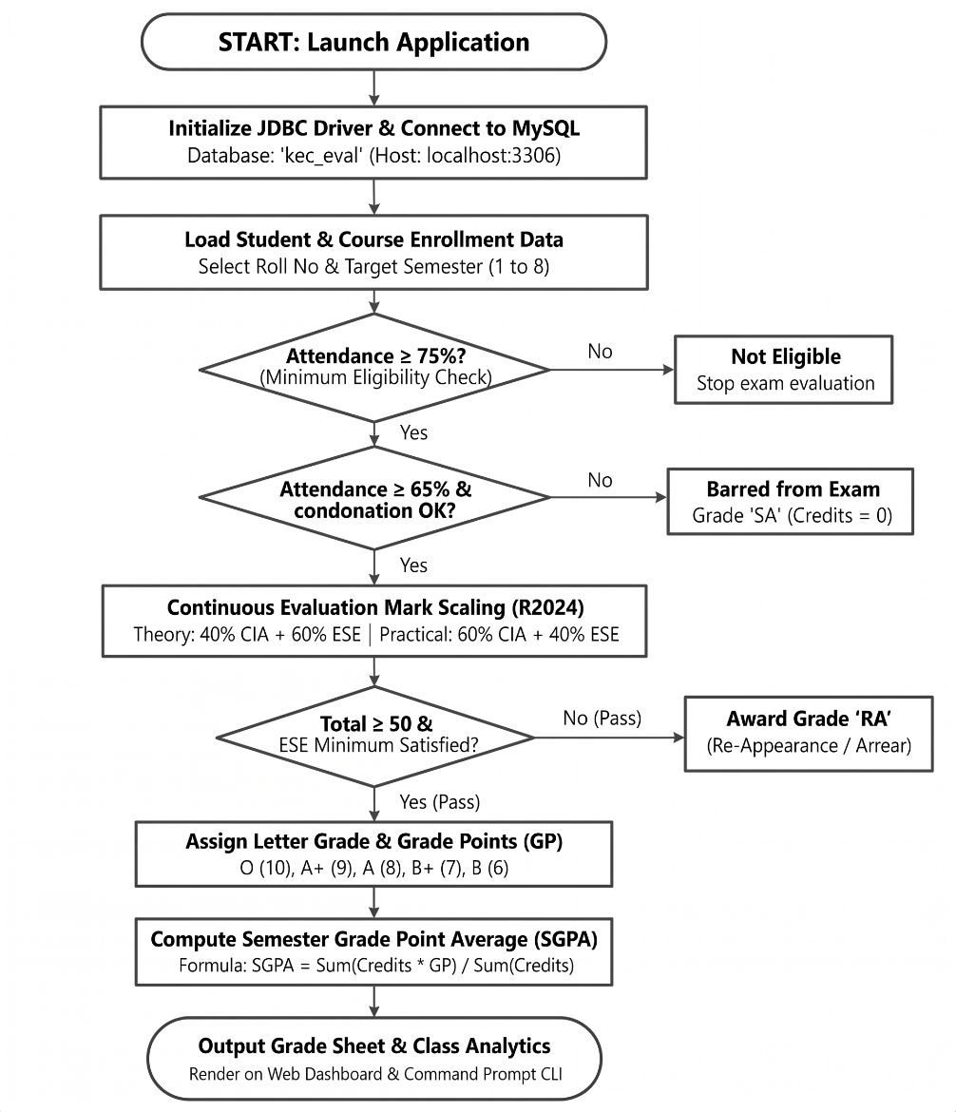
PROCEDURE:
- Load the MySQL Connector/J driver to enable communication between the Java application and the MySQL database.

- Establish a connection to the kec_eval database running on the local MySQL server using DriverManager.getConnection().

- Store and retrieve student details, including roll number, name, department, and semester, along with course information such as course code, title, credits, and course type.

- Enroll students in semester courses, record the number of classes held and attended, and calculate the attendance percentage.

- Verify examination eligibility based on attendance percentage. Students with 75% or above are eligible, those with 65%–74% require medical condonation verification, and those below 65% are marked as Shortage of Attendance (SA).

- Record CIA-1, CIA-2, and assignment marks, and calculate the scaled internal assessment marks according to the specified theory and practical course weightages.

- Record end-semester examination marks out of 100, verify the minimum passing requirements, and scale the marks according to the applicable theory and practical .

- Calculate the total marks by combining scaled CIA and ESE marks. Assign letter grades and grade points according to the specified grading scale, marking students as RA if they fail the examination or score below the required passing mark.

- Generate student grade sheets, attendance shortage reports, and department-wise pass percentage reports. Display the results through the interactive web dashboard and the command prompt console.
DATABASE SCHEMA:

1.STUDENTS TABLE:
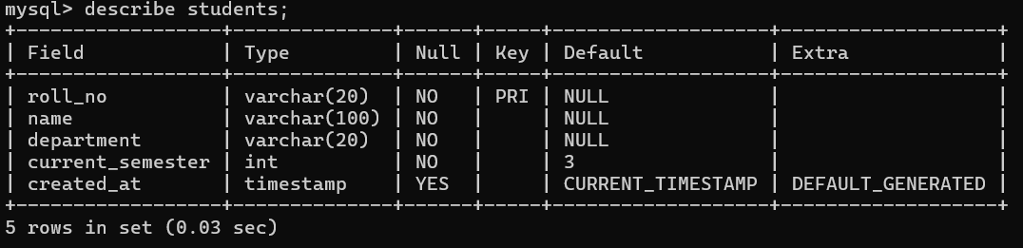
2. COURSES TABLE:
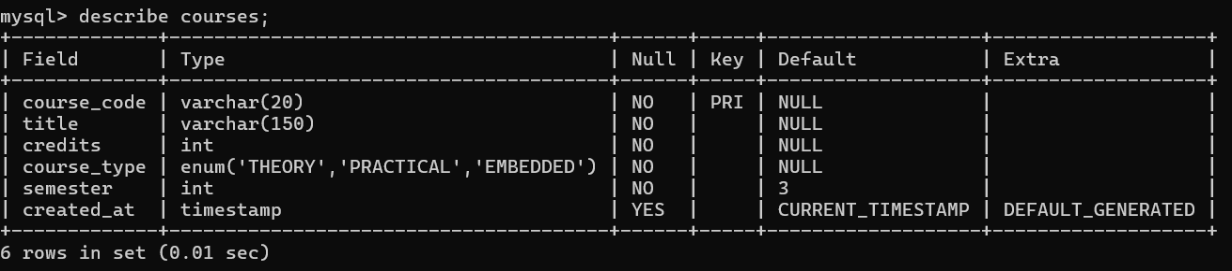
3. ENROLLMENTS TABLE:
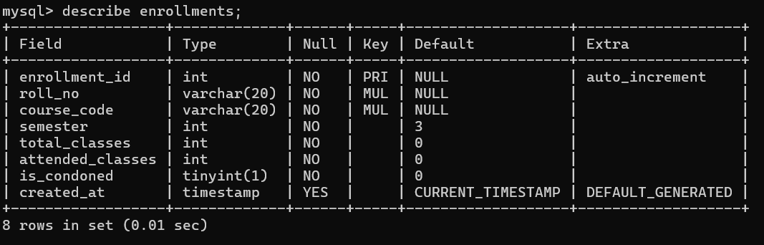

4. ASSESSMENT MARKS TABLE:
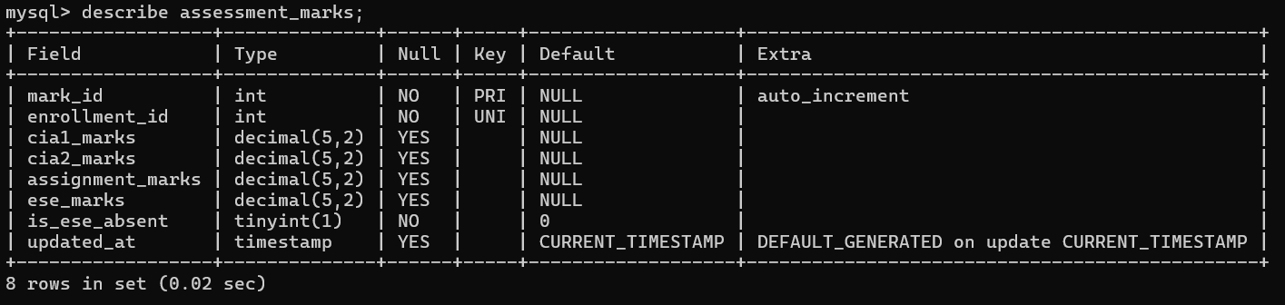
SOURCE CODE:
MAINAPP.JAVA:
import java.util.*;
import java.text.SimpleDateFormat;
/**
* KEC (Autonomous) - Regulation 2024
* Student Academic & Continuous Evaluation System
* Short documentation version of MainApp.java
*/
public class MainApp {
private static final AcademicDAO dao = new AcademicDAO();
private static final Scanner sc = new Scanner(System.in);
public static void main(String[] args) {
if (!DBConnection.testConnection()) {
System.out.println("Database connection failed. Check DBConnection.java.");
return;
}
System.out.println("KEC STUDENT EVALUATION SYSTEM - R2024");
boolean running = true;
while (running) {
System.out.println("\\n1.Student 2.Course 3.Enrollment/Attendance");
System.out.println("4.Enter Marks 5.Mark Sheet 6.Defaulters");
System.out.println("7.Department Summary 0.Exit");
System.out.print("Choice: ");
switch (sc.nextLine().trim()) {
case "1": registerStudent(); break;
case "2": addCourse(); break;
case "3": enrollStudent(); break;
case "4": enterMarks(); break;
case "5":
System.out.print("Roll number: ");
String roll = sc.nextLine().trim();
System.out.print("Semester: ");
printStudentMarkSheet(roll, Integer.parseInt(sc.nextLine().trim()));
break;
case "6":
System.out.print("Semester: ");
printAttendanceDefaulters(Integer.parseInt(sc.nextLine().trim()));
break;
case "7":
System.out.print("Semester: ");
printDepartmentSummary(Integer.parseInt(sc.nextLine().trim()));
break;
case "0": running = false; break;
default: System.out.println("Invalid choice.");
}
}
System.out.println("System closed.");
}
private static void enterMarks() {
System.out.print("Roll number: "); String roll = sc.nextLine().trim();
System.out.print("Course code: "); String course = sc.nextLine().trim();
System.out.print("Semester: "); int sem = Integer.parseInt(sc.nextLine().trim());
int id = dao.getEnrollmentId(roll, course, sem);
if (id <= 0) { System.out.println("Enrollment not found."); return; }
System.out.println("1.CIA marks 2.Assignment marks 3.ESE marks");
String phase = sc.nextLine().trim();
if (phase.equals("1")) {
System.out.print("CIA-1: "); double c1 = Double.parseDouble(sc.nextLine().trim());
System.out.print("CIA-2: "); double c2 = Double.parseDouble(sc.nextLine().trim());
System.out.println(dao.recordPhase1Marks(id, c1, c2) ? "Saved." : "Failed.");
} else if (phase.equals("2")) {
System.out.print("Assignment: "); double a = Double.parseDouble(sc.nextLine().trim());
System.out.println(dao.recordPhase2Marks(id, a) ? "Saved." : "Failed.");
} else if (phase.equals("3")) {
System.out.print("Absent in ESE? (y/n): "); boolean absent =
sc.nextLine().trim().equalsIgnoreCase("y");
Double marks = null;
if (!absent) {
System.out.print("ESE marks: "); marks = Double.parseDouble(sc.nextLine().trim());
}
System.out.println(dao.recordPhase3Marks(id, marks, absent) ? "Saved." : "Failed.");
} else System.out.println("Invalid phase.");
}

DB CONNECTION.JAVA:
import java.sql.Connection;
import java.sql.DriverManager;
import java.sql.SQLException;

/**
* DBConnection - Database Connection Management for KEC Evaluation System
* Kongu Engineering College (Autonomous) - Regulation 2024
*/
public class DBConnection {
private static final String DEFAULT_HOST = "localhost";
private static final String DEFAULT_PORT = "3306";
private static final String DEFAULT_DB = "kec_eval";
private static final String DEFAULT_USER = "root";
private static final String DEFAULT_PASS = "0000";

public static String getUrl() {
String host = System.getenv("DB_HOST") != null ? System.getenv("DB_HOST") : DEFAULT_HOST;
String port = System.getenv("DB_PORT") != null ? System.getenv("DB_PORT") : DEFAULT_PORT;
String db = System.getenv("DB_NAME") != null ? System.getenv("DB_NAME") : DEFAULT_DB;
return "jdbc:mysql://" + host + ":" + port + "/" + db + "?useSSL=false&allowPublicKeyRetrieval=true&serverTimezone=UTC";
}

public static String getUser() {
return System.getenv("DB_USER") != null ? System.getenv("DB_USER") : DEFAULT_USER;
}

public static String getPassword() {
return System.getenv("DB_PASSWORD") != null ? System.getenv("DB_PASSWORD") : DEFAULT_PASS;
}

static {
try {
Class.forName("com.mysql.cj.jdbc.Driver");
} catch (ClassNotFoundException e) {
System.err.println("[ERROR] MySQL JDBC Driver not found in classpath: " + e.getMessage());
}
}

/**
* Obtains a new database connection
*/
public static Connection getConnection() throws SQLException {
return DriverManager.getConnection(getUrl(), getUser(), getPassword());
}

/**
* Tests the database connectivity
*/
public static boolean testConnection() {
try (Connection conn = getConnection()) {
return conn != null && !conn.isClosed();
}

AcademicDOA.java:
timport java.math.BigDecimal;
import java.sql.Connection;
import java.sql.PreparedStatement;
import java.sql.ResultSet;
import java.sql.SQLException;
import java.sql.Types;
import java.util.ArrayList;
import java.util.HashMap;
import java.util.LinkedHashMap;
import java.util.List;
import java.util.Map;

/**
* AcademicDAO.java
* -------------------------------------------------------------------------
* Core business and data access logic for Kongu Engineering College (R2024)
* Student Academic & Continuous Evaluation System.
*
* Covers:
* 1. Course Enrollment and Attendance Tracking
* 2. Phased Incremental Assessment Updates (CIA 1, CIA 2, Assignments, ESE)
* 3. Configurable Internal Continuous Assessment (CIA) formulas
* 4. Strict R2024 Course-Type Evaluation Rules (THEORY, PRACTICAL, EMBEDDED)
* 5. Attendance Eligibility and Condonation processing
* 6. Semester Mark Sheet generation with SGPA and equivalent percentage
* 7. Attendance Defaulters Report
* 8. Department Performance Summary
* -------------------------------------------------------------------------
*/
public class AcademicDAO {

// =========================================================================
// Configurable CIA Calculation Formula
// =========================================================================
public enum CIAFormula {
WEIGHTED_40_40_20, // (CIA1 * 0.40) + (CIA2 * 0.40) + (Assignment * 0.20) [Default KEC assumption]
AVERAGE_CIA_80_ASSGN_20, // ((CIA1 + CIA2)/2 * 0.80) + (Assignment * 0.20)
EQUAL_WEIGHT // (CIA1 + CIA2 + Assignment) / 3.0
}

private static CIAFormula activeFormula = CIAFormula.WEIGHTED_40_40_20;

public static CIAFormula getActiveFormula() {
return activeFormula;
}

public static void setActiveFormula(CIAFormula formula) {
if (formula != null) {
activeFormula = formula;
}
}

// =========================================================================
// Data Transfer Objects (DTOs) for Clean Reporting
// =========================================================================
public static class CourseEvaluationResult {
public String courseCode;
public String title;
public String courseType;
public int credits;
public int classesHeld;
public int classesAttended;
public double attendancePct;
public boolean medicalCondonation;
public boolean attendanceEligible;
public String attendanceStatusRemark; // ELIGIBLE, CONDONED, DEF_SA

public Double cia1;
public Double cia2;
public Double assignment;
public Double cia100; // Internal scaled out of 100
public Double ciaWeighted; // Weighted CIA contribution (e.g. 40, 60, or 50)

public Double eseRaw; // Raw ESE out of 100
public Double eseWeighted; // Weighted ESE contribution (e.g. 60, 40, or 50)
public boolean isAbsentEse;

public Double totalMarks; // Sum of weighted CIA + weighted ESE (0-100)
public String grade; // O, A+, A, B+, B, RA, SA, AB, PENDING
public Integer gradePoint; // 10, 9, 8, 7, 6, 0 (or null if pending)
public String resultStatus; // PASS, RE-APPEAR (RA), SHORTAGE (SA), ABSENT (AB), PENDING
public String failureReason; // Null if pass; details if failed
}

public static class SemesterMarkSheet {
public String rollNo;
public String studentName;
public String department;
public int semester;
public List<CourseEvaluationResult> courses = new ArrayList<>();
public int totalRegisteredCredits;
public int earnedCredits;
public Double sgpa; // Null if any course is pending
public Double equivalentPercentage; // Null if any course is pending
public boolean isPending;
public int passedCoursesCount;
public int failedCoursesCount;
public int pendingCoursesCount;
}

public static class AttendanceDefaulterItem {
public String rollNo;
public String studentName;
public String department;
public int semester;
public String courseCode;
public String courseTitle;
public int classesHeld;
public int classesAttended;
public double attendancePct;
public boolean condonationApproved;
public String statusRemark;
}

public static class DepartmentSummary {
public String department;
public int totalStudents;
public int totalEnrollments;
public int passedCount;
public int failedRACount;
public int absentABCount;
public int shortageSACount;
public int pendingCount;
public double classAverageSGPA;
public int studentsWithFinalSGPA;
}

// =========================================================================
// 1. Enrollment & Attendance Operations
// =========================================================================

/**
* Enrolls a student in a course for a semester and initializes attendance.
*/
public boolean enrollStudent(String rollNo, String courseCode, int semester,
int classesHeld, int classesAttended, boolean condonation) {
if (rollNo == null || courseCode == null) return false;
if (classesHeld < 0 || classesAttended < 0 || classesAttended > classesHeld) {
System.err.println("[VALIDATION ERROR] Classes attended must be >= 0 and <= classes held.");
return false;
}

String sql = "INSERT INTO enrollments (roll_no, course_code, semester, " +
"classes_held, classes_attended, medical_condonation_approved) " +
"VALUES (?, ?, ?, ?, ?, ?) " +
"ON DUPLICATE KEY UPDATE classes_held = VALUES(classes_held), " +
"classes_attended = VALUES(classes_attended), " +
"medical_condonation_approved = VALUES(medical_condonation_approved)";

try (Connection conn = DBConnection.getConnection();
PreparedStatement pstmt = conn.prepareStatement(sql)) {

pstmt.setString(1, rollNo.trim().toUpperCase());
pstmt.setString(2, courseCode.trim().toUpperCase());
pstmt.setInt(3, semester);
pstmt.setInt(4, classesHeld);
pstmt.setInt(5, classesAttended);
pstmt.setBoolean(6, condonation);

return pstmt.executeUpdate() > 0;
} catch (SQLException e) {
System.err.println("[SQL ERROR] Failed to enroll student: " + e.getMessage());
return false;
}
}

/**
* Updates attendance details for an enrollment identified by roll number, course code, and semester.
*/
public boolean updateAttendance(String rollNo, String courseCode, int semester,
int classesHeld, int classesAttended, boolean condonation) {
if (classesHeld < 0 || classesAttended < 0 || classesAttended > classesHeld) {
System.err.println("[VALIDATION ERROR] Classes attended must be between 0 and classes held (" + classesHeld + ").");
return false;
}

String sql = "UPDATE enrollments SET classes_held = ?, classes_attended = ?, medical_condonation_approved = ? " +
"WHERE roll_no = ? AND course_code = ? AND semester = ?";

try (Connection conn = DBConnection.getConnection();
PreparedStatement pstmt = conn.prepareStatement(sql)) {

pstmt.setInt(1, classesHeld);
pstmt.setInt(2, classesAttended);
pstmt.setBoolean(3, condonation);
pstmt.setString(4, rollNo.trim().toUpperCase());
pstmt.setString(5, courseCode.trim().toUpperCase());
pstmt.setInt(6, semester);

int updated = pstmt.executeUpdate();
return updated > 0;
} catch (SQLException e) {
System.err.println("[SQL ERROR] Failed to update attendance: " + e.getMessage());
return false;
}
}

/**
* Resolves an enrollment ID for a student, course, and semester.
*/
public Integer getEnrollmentId(String rollNo, String courseCode, int semester) {
String sql = "SELECT enrollment_id FROM enrollments WHERE roll_no = ? AND course_code = ? AND semester = ?";
try (Connection conn = DBConnection.getConnection();
PreparedStatement pstmt = conn.prepareStatement(sql)) {

pstmt.setString(1, rollNo.trim().toUpperCase());
pstmt.setString(2, courseCode.trim().toUpperCase());
pstmt.setInt(3, semester);

try (ResultSet rs = pstmt.executeQuery()) {
if (rs.next()) {
return rs.getInt("enrollment_id");
}
}
} catch (SQLException e) {
System.err.println("[SQL ERROR] Failed to find enrollment: " + e.getMessage());
}
return null;
}

// =========================================================================
// 2. Incremental Assessment Marks Entry (Preserving Existing Marks)
// =========================================================================

/**
* Helper to ensure an assessment_marks row exists for an enrollment.
*/
private void ensureAssessmentRecordExists(Connection conn, int enrollmentId) throws SQLException {
String checkSql = "SELECT 1 FROM assessment_marks m JOIN enrollments e ON m.roll_no = e.roll_no AND m.course_code = e.course_code WHERE e.enrollment_id = ?";
try (PreparedStatement checkStmt = conn.prepareStatement(checkSql)) {
checkStmt.setInt(1, enrollmentId);
try (ResultSet rs = checkStmt.executeQuery()) {
if (!rs.next()) {
String insertSql = "INSERT INTO assessment_marks (roll_no, course_code) SELECT roll_no, course_code FROM enrollments WHERE enrollment_id = ?";
try (PreparedStatement insertStmt = conn.prepareStatement(insertSql)) {
insertStmt.setInt(1, enrollmentId);
insertStmt.executeUpdate();
}
}
}
}
}

/**
* Phase 1: Enter / Update CIA 1 (scale 0 - 100).
*/
public boolean updateCia1(int enrollmentId, double marks) {
if (marks < 0.0 || marks > 100.0) {
System.err.println("[VALIDATION ERROR] CIA 1 marks must be between 0 and 100.");
return false;
}

try (Connection conn = DBConnection.getConnection()) {
ensureAssessmentRecordExists(conn, enrollmentId);
String sql = "UPDATE assessment_marks m JOIN enrollments e ON m.roll_no = e.roll_no AND m.course_code = e.course_code SET m.cia1 = ? WHERE e.enrollment_id = ?";
try (PreparedStatement pstmt = conn.prepareStatement(sql)) {
pstmt.setDouble(1, marks);
pstmt.setInt(2, enrollmentId);
return pstmt.executeUpdate() > 0;
}
} catch (SQLException e) {
System.err.println("[SQL ERROR] Failed to update CIA 1: " + e.getMessage());
return false;
}
}

/**
* Phase 1: Enter / Update CIA 2 (scale 0 - 100).
*/
public boolean updateCia2(int enrollmentId, double marks) {
if (marks < 0.0 || marks > 100.0) {
System.err.println("[VALIDATION ERROR] CIA 2 marks must be between 0 and 100.");
return false;
}

try (Connection conn = DBConnection.getConnection()) {
ensureAssessmentRecordExists(conn, enrollmentId);
String sql = "UPDATE assessment_marks m JOIN enrollments e ON m.roll_no = e.roll_no AND m.course_code = e.course_code SET m.cia2 = ? WHERE e.enrollment_id = ?";
try (PreparedStatement pstmt = conn.prepareStatement(sql)) {
pstmt.setDouble(1, marks);
pstmt.setInt(2, enrollmentId);
return pstmt.executeUpdate() > 0;
}
} catch (SQLException e) {
System.err.println("[SQL ERROR] Failed to update CIA 2: " + e.getMessage());
return false;
}
}

/**
* Phase 2: Enter / Update Assignments / Quizzes / Lab Evaluations (scale 0 - 100).
*/
public boolean updateAssignmentQuizLab(int enrollmentId, double marks) {
if (marks < 0.0 || marks > 100.0) {
System.err.println("[VALIDATION ERROR] Assignment/Quiz/Lab marks must be between 0 and 100.");
return false;
}

try (Connection conn = DBConnection.getConnection()) {
ensureAssessmentRecordExists(conn, enrollmentId);
String sql = "UPDATE assessment_marks m JOIN enrollments e ON m.roll_no = e.roll_no AND m.course_code = e.course_code SET m.coursework = ? WHERE e.enrollment_id = ?";
try (PreparedStatement pstmt = conn.prepareStatement(sql)) {
pstmt.setDouble(1, marks);
pstmt.setInt(2, enrollmentId);
return pstmt.executeUpdate() > 0;
}
} catch (SQLException e) {
System.err.println("[SQL ERROR] Failed to update Assignment/Quiz/Lab: " + e.getMessage());
return false;
}
}

/**
* Phase 3: Enter End Semester Examination (ESE) mark or mark Absent (AB).
* If isAbsent is true, mark is treated as absent (ese column set to null, is_absent_ese = true).
* Otherwise, validate mark (0 - 100), set ese, and set is_absent_ese = false.
*/
public boolean updateEse(int enrollmentId, Double marks, boolean isAbsent) {
if (!isAbsent) {
if (marks == null || marks < 0.0 || marks > 100.0) {
System.err.println("[VALIDATION ERROR] ESE marks must be between 0 and 100.");
return false;
}
}

try (Connection conn = DBConnection.getConnection()) {
ensureAssessmentRecordExists(conn, enrollmentId);
String sql = "UPDATE assessment_marks m JOIN enrollments e ON m.roll_no = e.roll_no AND m.course_code = e.course_code SET m.ese_marks = ?, m.ese_absent = ? WHERE e.enrollment_id = ?";
try (PreparedStatement pstmt = conn.prepareStatement(sql)) {
if (isAbsent) {
pstmt.setNull(1, Types.DECIMAL);
pstmt.setBoolean(2, true);
} else {
pstmt.setDouble(1, marks);
pstmt.setBoolean(2, false);
}
pstmt.setInt(3, enrollmentId);
return pstmt.executeUpdate() > 0;
}
} catch (SQLException e) {
System.err.println("[SQL ERROR] Failed to update ESE: " + e.getMessage());
return false;
}
}

// =========================================================================
// 3. Evaluation Rules & Internal Assessment Conversion
// =========================================================================

/**
* Computes the combined Continuous Internal Assessment (out of 100) using the
* active formula. Returns null if any required component is missing.
*/
public static Double computeCiaOutOf100(Double cia1, Double cia2, Double assignment) {
if (cia1 == null || cia2 == null || assignment == null) {
return null; // Incomplete assessment
}

switch (activeFormula) {
case AVERAGE_CIA_80_ASSGN_20:
double ciaAvg = (cia1 + cia2) / 2.0;
return (ciaAvg * 0.80) + (assignment * 0.20);
case EQUAL_WEIGHT:
return (cia1 + cia2 + assignment) / 3.0;
case WEIGHTED_40_40_20:
default:
// Official KEC R2024 Working Assumption:
// CIA 1: 40%, CIA 2: 40%, Assignments/Tutorials/Quizzes: 20%
return (cia1 * 0.40) + (cia2 * 0.40) + (assignment * 0.20);
}
}

/**
* Evaluates a single course enrollment under KEC R2024 regulations.
*/
public static CourseEvaluationResult evaluateCourse(
String courseCode, String title, String courseType, int credits,
int classesHeld, int classesAttended, boolean medicalCondonation,
Double cia1, Double cia2, Double assignment, Double ese, boolean isAbsentEse) {

CourseEvaluationResult res = new CourseEvaluationResult();
res.courseCode = courseCode;
res.title = title;
res.courseType = courseType.toUpperCase();
res.credits = credits;
res.classesHeld = classesHeld;
res.classesAttended = classesAttended;
res.medicalCondonation = medicalCondonation;
res.cia1 = cia1;
res.cia2 = cia2;
res.assignment = assignment;
res.eseRaw = ese;
res.isAbsentEse = isAbsentEse;

// 1. Calculate Attendance Percentage
if (classesHeld > 0) {
res.attendancePct = ((double) classesAttended / classesHeld) * 100.0;
} else {
res.attendancePct = 100.0; // Default when no classes recorded yet
}

// 2. Attendance Eligibility Evaluation
// Rules:
// >= 75% : Eligible
// 65% <= Att < 75% : Conditionally eligible; needs medical condonation
// < 65% : SA (Shortage of Attendance, Barred from ESE, GP 0)
if (res.attendancePct >= 75.0) {
res.attendanceEligible = true;
res.attendanceStatusRemark = "ELIGIBLE";
} else if (res.attendancePct >= 65.0) {
if (medicalCondonation) {
res.attendanceEligible = true;
res.attendanceStatusRemark = "CONDONED (ELIGIBLE)";
} else {
res.attendanceEligible = false;
res.attendanceStatusRemark = "SA (NO CONDONATION)";
}
} else {
res.attendanceEligible = false;
res.attendanceStatusRemark = "SA (DEF_BELOW_65)";
}

// If attendance shortage: immediate SA status
if (!res.attendanceEligible) {
res.grade = "SA";
res.gradePoint = 0;
res.resultStatus = "FAIL (SA)";
res.failureReason = String.format("Attendance Shortage (%.1f%%) - Barred from ESE", res.attendancePct);
return res;
}

// 3. ESE Absence Check
if (isAbsentEse) {
res.grade = "AB";
res.gradePoint = 0;
res.resultStatus = "ABSENT (AB)";
res.failureReason = "Absent in End Semester Examination";
return res;
}

// 4. Check for Pending Assessments
res.cia100 = computeCiaOutOf100(cia1, cia2, assignment);
if (res.cia100 == null || ese == null) {
res.grade = "PENDING";
res.gradePoint = null;
res.resultStatus = "PENDING";
res.failureReason = "Incomplete Marks (Awaiting CIA components or ESE)";
return res;
}

// 5. Weightage Calculation by Course Type
double ciaWeightPct;
double eseWeightPct;
double minEseContrib;

switch (res.courseType) {
case "PRACTICAL":
ciaWeightPct = 0.60;
eseWeightPct = 0.40;
minEseContrib = 20.0; // 20 / 40
break;
case "EMBEDDED":
ciaWeightPct = 0.50;
eseWeightPct = 0.50;
minEseContrib = 22.5; // 22.5 / 50
break;
case "THEORY":
default:
ciaWeightPct = 0.40;
eseWeightPct = 0.60;
minEseContrib = 27.0; // 27 / 60
break;
}

res.ciaWeighted = res.cia100 * ciaWeightPct;
res.eseWeighted = (ese / 100.0) * (eseWeightPct * 100.0);
res.totalMarks = res.ciaWeighted + res.eseWeighted;

// 6. Pass / Fail Verification
// Condition: ESE contribution >= minimum required AND total marks >= 50
boolean passedEseMin = res.eseWeighted >= (minEseContrib - 1e-6);
boolean passedTotal = res.totalMarks >= 50.0;

if (passedEseMin && passedTotal) {
res.resultStatus = "PASS";
// KEC R2024 Grade Thresholds
double total = Math.round(res.totalMarks * 100.0) / 100.0;
if (total >= 91.0) {
res.grade = "O";
res.gradePoint = 10;
} else if (total >= 81.0) {
res.grade = "A+";
res.gradePoint = 9;
} else if (total >= 71.0) {
res.grade = "A";
res.gradePoint = 8;
} else if (total >= 61.0) {
res.grade = "B+";
res.gradePoint = 7;
} else { // 50 to 60.99
res.grade = "B";
res.gradePoint = 6;
}
} else {
res.grade = "RA";
res.gradePoint = 0;
res.resultStatus = "RE-APPEAR (RA)";
if (!passedEseMin && !passedTotal) {
res.failureReason = String.format("Failed ESE minimum (%.2f < %.1f) & Total < 50 (%.2f)",
res.eseWeighted, minEseContrib, res.totalMarks);
} else if (!passedEseMin) {
res.failureReason = String.format("Failed ESE minimum requirement (%.2f < %.1f)",
res.eseWeighted, minEseContrib);
} else {
res.failureReason = String.format("Overall total below pass mark (%.2f < 50.0)", res.totalMarks);
}
}

return res;
}

// =========================================================================
// 4. Semester Mark Sheet & SGPA Generation
// =========================================================================

private static Double getNullableDouble(ResultSet rs, String colName) throws SQLException {
BigDecimal bd = rs.getBigDecimal(colName);
return (bd != null) ? bd.doubleValue() : null;
}

/**
* Generates a comprehensive semester mark sheet for a student and semester.
*/
public SemesterMarkSheet generateSemesterMarkSheet(String rollNo, int semester) {
if (rollNo == null) return null;

String studentSql = "SELECT roll_no, student_name, department FROM students WHERE roll_no = ?";
SemesterMarkSheet sheet = new SemesterMarkSheet();
sheet.rollNo = rollNo.trim().toUpperCase();
sheet.semester = semester;

try (Connection conn = DBConnection.getConnection();
PreparedStatement studentStmt = conn.prepareStatement(studentSql)) {

studentStmt.setString(1, sheet.rollNo);
try (ResultSet rs = studentStmt.executeQuery()) {
if (rs.next()) {
sheet.studentName = rs.getString("student_name");
sheet.department = rs.getString("department");
} else {
return null; // Student not found
}
}

String evalSql =
"SELECT e.enrollment_id, e.course_code, c.title, c.credits, c.course_type, " +
" e.classes_held, e.classes_attended, e.medical_condonation_approved, " +
" m.cia1, m.cia2, m.coursework, m.ese_marks, m.ese_absent " +
"FROM enrollments e " +
"JOIN courses c ON e.course_code = c.course_code " +
"LEFT JOIN assessment_marks m ON e.roll_no = m.roll_no AND e.course_code = m.course_code " +
"WHERE e.roll_no = ? AND e.semester = ? " +
"ORDER BY e.course_code";

try (PreparedStatement evalStmt = conn.prepareStatement(evalSql)) {
evalStmt.setString(1, sheet.rollNo);
evalStmt.setInt(2, semester);

try (ResultSet rs = evalStmt.executeQuery()) {
int totalCreds = 0;
int earnedCreds = 0;
double weightedGradePointSum = 0.0;
boolean anyPending = false;

while (rs.next()) {
String code = rs.getString("course_code");
String title = rs.getString("title");
String type = rs.getString("course_type");
int creds = rs.getInt("credits");
int held = rs.getInt("classes_held");
int attended = rs.getInt("classes_attended");
boolean condonation = rs.getBoolean("medical_condonation_approved");

Double cia1 = getNullableDouble(rs, "cia1");
Double cia2 = getNullableDouble(rs, "cia2");
Double assgn = getNullableDouble(rs, "coursework");
Double ese = getNullableDouble(rs, "ese_marks");
boolean isAbsent = rs.getBoolean("ese_absent");

CourseEvaluationResult eval = evaluateCourse(
code, title, type, creds, held, attended, condonation,
cia1, cia2, assgn, ese, isAbsent
);

sheet.courses.add(eval);
totalCreds += creds;

if ("PENDING".equals(eval.grade)) {
anyPending = true;
sheet.pendingCoursesCount++;
} else if ("PASS".equals(eval.resultStatus)) {
earnedCreds += creds;
sheet.passedCoursesCount++;
weightedGradePointSum += (creds * eval.gradePoint);
} else {
sheet.failedCoursesCount++;
// Grade point is 0 for RA, SA, AB
weightedGradePointSum += (creds * 0);
}
}

sheet.totalRegisteredCredits = totalCreds;
sheet.earnedCredits = earnedCreds;
sheet.isPending = anyPending;

// SGPA calculation:
// If any course is PENDING, final SGPA cannot be definitively finalized.
if (!anyPending && totalCreds > 0) {
sheet.sgpa = Math.round((weightedGradePointSum / totalCreds) * 100.0) / 100.0;
sheet.equivalentPercentage = Math.round((sheet.sgpa * 10.0) * 100.0) / 100.0;
} else {
sheet.sgpa = null;
sheet.equivalentPercentage = null;
}
}
}

} catch (SQLException e) {
System.err.println("[SQL ERROR] Failed to generate semester mark sheet: " + e.getMessage());
}

return sheet;
}

// =========================================================================
// 5. Attendance Defaulters Report
// =========================================================================

/**
* Finds all students with attendance below 65% OR between 65%-74.9% without medical condonation.
*/
public List<AttendanceDefaulterItem> getAttendanceDefaulters() {
List<AttendanceDefaulterItem> list = new ArrayList<>();

String sql =
"SELECT s.roll_no, s.student_name, s.department, e.semester, " +
" e.course_code, c.title, e.classes_held, e.classes_attended, e.medical_condonation_approved " +
"FROM enrollments e " +
"JOIN students s ON e.roll_no = s.roll_no " +
"JOIN courses c ON e.course_code = c.course_code " +
"WHERE e.classes_held > 0 " +
"ORDER BY s.department, s.roll_no, e.course_code";

try (Connection conn = DBConnection.getConnection();
PreparedStatement pstmt = conn.prepareStatement(sql);
ResultSet rs = pstmt.executeQuery()) {

while (rs.next()) {
int held = rs.getInt("classes_held");
int attended = rs.getInt("classes_attended");
boolean condonation = rs.getBoolean("medical_condonation_approved");
double pct = ((double) attended / held) * 100.0;

boolean isDefaulter = false;
String remark = "";

if (pct < 65.0) {
isDefaulter = true;
remark = "Below 65% (Barred - SA)";
} else if (pct < 75.0 && !condonation) {
isDefaulter = true;
remark = "65%-74% Lacks Condonation Approval (Barred - SA)";
}

if (isDefaulter) {
AttendanceDefaulterItem item = new AttendanceDefaulterItem();
item.rollNo = rs.getString("roll_no");
item.studentName = rs.getString("student_name");
item.department = rs.getString("department");
item.semester = rs.getInt("semester");
item.courseCode = rs.getString("course_code");
item.courseTitle = rs.getString("title");
item.classesHeld = held;
item.classesAttended = attended;
item.attendancePct = pct;
item.condonationApproved = condonation;
item.statusRemark = remark;
list.add(item);
}
}

} catch (SQLException e) {
System.err.println("[SQL ERROR] Failed to fetch attendance defaulters: " + e.getMessage());
}

return list;
}

// =========================================================================
// 6. Department Performance Summary
// =========================================================================

/**
* Generates department-wise pass, fail (RA/SA/AB), pending metrics and average class SGPA.
*/
public List<DepartmentSummary> getDepartmentPerformanceSummary() {
Map<String, DepartmentSummary> deptMap = new LinkedHashMap<>();
Map<String, List<Double>> deptSgpas = new HashMap<>();

// 1. Fetch all distinct departments from students
String deptSql = "SELECT DISTINCT department FROM students ORDER BY department";
try (Connection conn = DBConnection.getConnection();
PreparedStatement pstmt = conn.prepareStatement(deptSql);
ResultSet rs = pstmt.executeQuery()) {

while (rs.next()) {
String dept = rs.getString("department");
DepartmentSummary sum = new DepartmentSummary();
sum.department = dept;
deptMap.put(dept, sum);
deptSgpas.put(dept, new ArrayList<>());
}
} catch (SQLException e) {
System.err.println("[SQL ERROR] Failed to fetch departments: " + e.getMessage());
return new ArrayList<>();
}

// 2. Count total students per department
String studentCountSql = "SELECT department, COUNT(*) as count FROM students GROUP BY department";
try (Connection conn = DBConnection.getConnection();
PreparedStatement pstmt = conn.prepareStatement(studentCountSql);
ResultSet rs = pstmt.executeQuery()) {

while (rs.next()) {
String dept = rs.getString("department");
if (deptMap.containsKey(dept)) {
deptMap.get(dept).totalStudents = rs.getInt("count");
}
}
} catch (SQLException e) {
System.err.println("[SQL ERROR] Failed to count students by department: " + e.getMessage());
}

// 3. Evaluate all students to collect per-department course results and final SGPAs
String allStudentsSql = "SELECT roll_no, current_semester, department FROM students";
try (Connection conn = DBConnection.getConnection();
PreparedStatement pstmt = conn.prepareStatement(allStudentsSql);
ResultSet rs = pstmt.executeQuery()) {

while (rs.next()) {
String rollNo = rs.getString("roll_no");
int sem = rs.getInt("current_semester");
String dept = rs.getString("department");

SemesterMarkSheet sheet = generateSemesterMarkSheet(rollNo, sem);
if (sheet != null && deptMap.containsKey(dept)) {
DepartmentSummary sum = deptMap.get(dept);
sum.totalEnrollments += sheet.courses.size();

for (CourseEvaluationResult eval : sheet.courses) {
if ("PASS".equals(eval.resultStatus)) {
sum.passedCount++;
} else if ("RE-APPEAR (RA)".equals(eval.resultStatus)) {
sum.failedRACount++;
} else if ("FAIL (SA)".equals(eval.resultStatus)) {
sum.shortageSACount++;
} else if ("ABSENT (AB)".equals(eval.resultStatus)) {
sum.absentABCount++;
} else {
sum.pendingCount++;
}
}

if (sheet.sgpa != null) {
deptSgpas.get(dept).add(sheet.sgpa);
}
}
}

} catch (SQLException e) {
System.err.println("[SQL ERROR] Failed to compute department performance: " + e.getMessage());
}

// 4. Calculate Department Average SGPAs
for (Map.Entry<String, DepartmentSummary> entry : deptMap.entrySet()) {
DepartmentSummary sum = entry.getValue();
List<Double> sgpaList = deptSgpas.get(entry.getKey());
sum.studentsWithFinalSGPA = sgpaList.size();
if (!sgpaList.isEmpty()) {
double total = 0.0;
for (double d : sgpaList) total += d;
sum.classAverageSGPA = Math.round((total / sgpaList.size()) * 100.0) / 100.0;
} else {
sum.classAverageSGPA = 0.0;
}
}

return new ArrayList<>(deptMap.values());
}
StudentDOA.java:
import java.sql.Connection;
import java.sql.PreparedStatement;
import java.sql.ResultSet;
import java.sql.SQLException;
import java.util.ArrayList;
import java.util.List;

/**
* StudentDAO.java
* -------------------------------------------------------------------------
* Data Access Object (DAO) for managing Student and Course entities in the
* Kongu Engineering College (R2024) Evaluation System.
*
* Implements:
* - Full CRUD operations using PreparedStatements to prevent SQL injection.
* - Proper connection and statement lifecycle via try-with-resources.
* - Input validation aligned with KEC R2024 schema constraints.
* -------------------------------------------------------------------------
*/
public class StudentDAO {

// =========================================================================
// Student Entity Model
// =========================================================================
public static class Student {
private String rollNo;
private String name;
private String department;
private int currentSemester;

public Student(String rollNo, String name, String department, int currentSemester) {
this.rollNo = rollNo;
this.name = name;
this.department = department;
this.currentSemester = currentSemester;
}

public String getRollNo() { return rollNo; }
public String getName() { return name; }
public String getDepartment() { return department; }
public int getCurrentSemester() { return currentSemester; }

public void setName(String name) { this.name = name; }
public void setDepartment(String department) { this.department = department; }
public void setCurrentSemester(int currentSemester) { this.currentSemester = currentSemester; }

@Override
public String toString() {
return String.format("[Roll: %-10s | Name: %-25s | Dept: %-30s | Sem: %d]",
rollNo, name, department, currentSemester);
}
}

// =========================================================================
// Course Entity Model
// =========================================================================
public static class Course {
private String courseCode;
private String title;
private int credits;
private String courseType; // THEORY, PRACTICAL, EMBEDDED

public Course(String courseCode, String title, int credits, String courseType) {
this.courseCode = courseCode;
this.title = title;
this.credits = credits;
this.courseType = courseType;
}

public String getCourseCode() { return courseCode; }
public String getTitle() { return title; }
public int getCredits() { return credits; }
public String getCourseType() { return courseType; }

public void setTitle(String title) { this.title = title; }
public void setCredits(int credits) { this.credits = credits; }
public void setCourseType(String courseType) { this.courseType = courseType; }

@Override
public String toString() {
return String.format("[Code: %-10s | Title: %-35s | Credits: %d | Type: %-9s]",
courseCode, title, credits, courseType);
}
}

// =========================================================================
// Student CRUD Operations
// =========================================================================

/**
* Adds a new student record to the database.
*
* @param rollNo Unique student roll number (e.g. 24ITR001)
* @param name Full name of student
* @param department Department (e.g. Information Technology)
* @param currentSemester Semester number (1 to 8)
* @return true if added successfully, false otherwise
*/
public boolean addStudent(String rollNo, String name, String department, int currentSemester) {
if (rollNo == null || rollNo.trim().isEmpty() ||
name == null || name.trim().isEmpty() ||
department == null || department.trim().isEmpty()) {
System.err.println("[VALIDATION ERROR] Student fields cannot be empty.");
return false;
}

if (currentSemester < 1 || currentSemester > 8) {
System.err.println("[VALIDATION ERROR] Current semester must be between 1 and 8.");
return false;
}

String sql = "INSERT INTO students (roll_no, student_name, department, current_semester) VALUES (?, ?, ?, ?)";

try (Connection conn = DBConnection.getConnection();
PreparedStatement pstmt = conn.prepareStatement(sql)) {

pstmt.setString(1, rollNo.trim().toUpperCase());
pstmt.setString(2, name.trim());
pstmt.setString(3, department.trim());
pstmt.setInt(4, currentSemester);

int rowsAffected = pstmt.executeUpdate();
return rowsAffected > 0;

} catch (SQLException e) {
System.err.println("[SQL ERROR] Failed to add student: " + e.getMessage());
return false;
}
}

/**
* Checks if a student with the given roll number exists.
*/
public boolean studentExists(String rollNo) {
if (rollNo == null || rollNo.trim().isEmpty()) return false;

String sql = "SELECT 1 FROM students WHERE roll_no = ?";
try (Connection conn = DBConnection.getConnection();
PreparedStatement pstmt = conn.prepareStatement(sql)) {

pstmt.setString(1, rollNo.trim().toUpperCase());
try (ResultSet rs = pstmt.executeQuery()) {
return rs.next();
}
} catch (SQLException e) {
System.err.println("[SQL ERROR] Failed to check student existence: " + e.getMessage());
return false;
}
}

/**
* Retrieves all student records ordered by department and roll number.
*/
public List<Student> getAllStudents() {
List<Student> list = new ArrayList<>();
String sql = "SELECT roll_no, student_name, department, current_semester FROM students ORDER BY department, roll_no";

try (Connection conn = DBConnection.getConnection();
PreparedStatement pstmt = conn.prepareStatement(sql);
ResultSet rs = pstmt.executeQuery()) {

while (rs.next()) {
list.add(new Student(
rs.getString("roll_no"),
rs.getString("student_name"),
rs.getString("department"),
rs.getInt("current_semester")
));
}
} catch (SQLException e) {
System.err.println("[SQL ERROR] Failed to fetch students: " + e.getMessage());
}
return list;
}

/**
* Retrieves a student by their unique roll number.
*/
public Student getStudentByRollNo(String rollNo) {
if (rollNo == null || rollNo.trim().isEmpty()) return null;

String sql = "SELECT roll_no, student_name, department, current_semester FROM students WHERE roll_no = ?";
try (Connection conn = DBConnection.getConnection();
PreparedStatement pstmt = conn.prepareStatement(sql)) {

pstmt.setString(1, rollNo.trim().toUpperCase());
try (ResultSet rs = pstmt.executeQuery()) {
if (rs.next()) {
return new Student(
rs.getString("roll_no"),
rs.getString("student_name"),
rs.getString("department"),
rs.getInt("current_semester")
);
}
}
} catch (SQLException e) {
System.err.println("[SQL ERROR] Failed to fetch student by roll number: " + e.getMessage());
}
return null;
}

// =========================================================================
// Course CRUD Operations
// =========================================================================

/**
* Adds a new course to the curriculum catalog.
*
* @param courseCode Unique course code (e.g. 24ITT31)
* @param title Course title
* @param credits Credits (1 to 10)
* @param courseType THEORY, PRACTICAL, or EMBEDDED
* @return true if added successfully, false otherwise
*/
public boolean addCourse(String courseCode, String title, int credits, String courseType) {
if (courseCode == null || courseCode.trim().isEmpty() ||
title == null || title.trim().isEmpty() ||
courseType == null || courseType.trim().isEmpty()) {
System.err.println("[VALIDATION ERROR] Course fields cannot be empty.");
return false;
}

String typeUpper = courseType.trim().toUpperCase();
if (!typeUpper.equals("THEORY") && !typeUpper.equals("PRACTICAL") && !typeUpper.equals("EMBEDDED")) {
System.err.println("[VALIDATION ERROR] Course type must be THEORY, PRACTICAL, or EMBEDDED.");
return false;
}

if (credits <= 0 || credits > 10) {
System.err.println("[VALIDATION ERROR] Credits must be between 1 and 10.");
return false;
}

String sql = "INSERT INTO courses (course_code, title, credits, course_type) VALUES (?, ?, ?, ?)";

try (Connection conn = DBConnection.getConnection();
PreparedStatement pstmt = conn.prepareStatement(sql)) {

pstmt.setString(1, courseCode.trim().toUpperCase());
pstmt.setString(2, title.trim());
pstmt.setInt(3, credits);
pstmt.setString(4, typeUpper);

int rowsAffected = pstmt.executeUpdate();
return rowsAffected > 0;

} catch (SQLException e) {
System.err.println("[SQL ERROR] Failed to add course: " + e.getMessage());
return false;
}
}

/**
* Checks if a course with the specified code exists.
*/
public boolean courseExists(String courseCode) {
if (courseCode == null || courseCode.trim().isEmpty()) return false;

String sql = "SELECT 1 FROM courses WHERE course_code = ?";
try (Connection conn = DBConnection.getConnection();
PreparedStatement pstmt = conn.prepareStatement(sql)) {

pstmt.setString(1, courseCode.trim().toUpperCase());
try (ResultSet rs = pstmt.executeQuery()) {
return rs.next();
}
} catch (SQLException e) {
System.err.println("[SQL ERROR] Failed to check course existence: " + e.getMessage());
return false;
}
}

/**
* Retrieves all courses ordered by course code.
*/
public List<Course> getAllCourses() {
List<Course> list = new ArrayList<>();
String sql = "SELECT course_code, title, credits, course_type FROM courses ORDER BY course_code";

try (Connection conn = DBConnection.getConnection();
PreparedStatement pstmt = conn.prepareStatement(sql);
ResultSet rs = pstmt.executeQuery()) {

while (rs.next()) {
list.add(new Course(
rs.getString("course_code"),
rs.getString("title"),
rs.getInt("credits"),
rs.getString("course_type")
));
}
} catch (SQLException e) {
System.err.println("[SQL ERROR] Failed to fetch courses: " + e.getMessage());
}
return list;
}

/**
* Retrieves a course by its course code.
*/
public Course getCourseByCode(String courseCode) {
if (courseCode == null || courseCode.trim().isEmpty()) return null;

String sql = "SELECT course_code, title, credits, course_type FROM courses WHERE course_code = ?";
try (Connection conn = DBConnection.getConnection();
PreparedStatement pstmt = conn.prepareStatement(sql)) {

pstmt.setString(1, courseCode.trim().toUpperCase());
try (ResultSet rs = pstmt.executeQuery()) {
if (rs.next()) {
return new Course(
rs.getString("course_code"),
rs.getString("title"),
rs.getInt("credits"),
rs.getString("course_type")
);
}
}
} catch (SQLException e) {
System.err.println("[SQL ERROR] Failed to fetch course by code: " + e.getMessage());
}
return null;
}
}

OUTPUT SCREENSHOTS:
MAIN MENU:
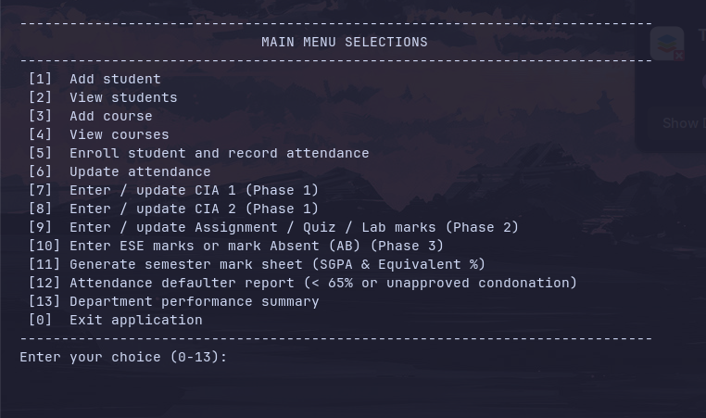
STUDENT & COURSE MANAGEMENT:
1.STUDENT REGISTRATION:
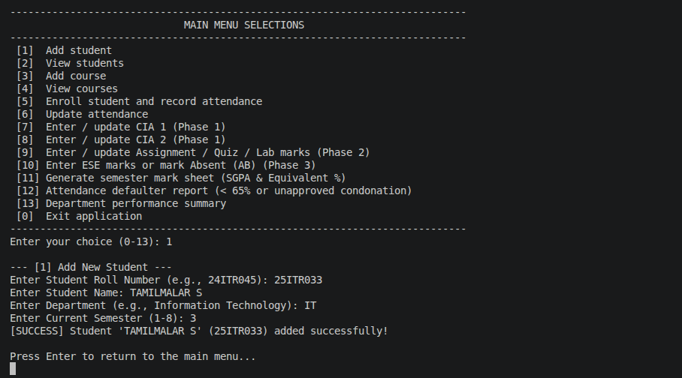

2. COURSE CATALOG:
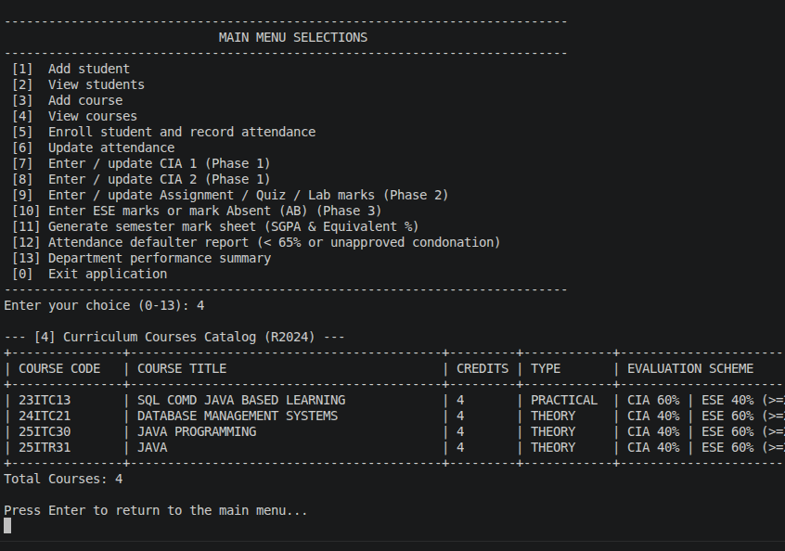

3. COURSE ENROLLMENT & ATTENDANCE TRACKING:
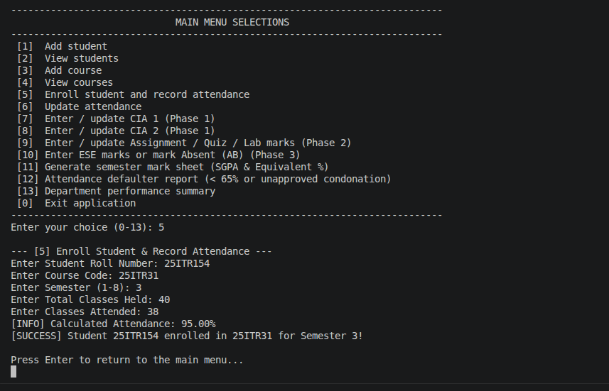

4. UPDATE ATTENDANCE:
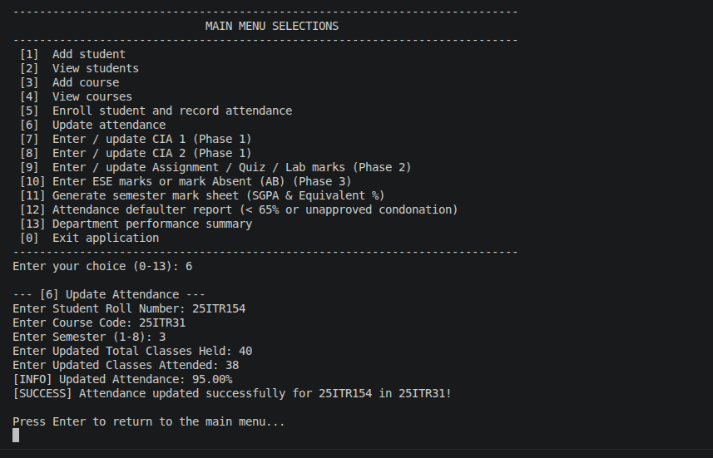

INCREMENTAL MARKS ENTRY:

1.PHASE 1 (ENTER-CIA):
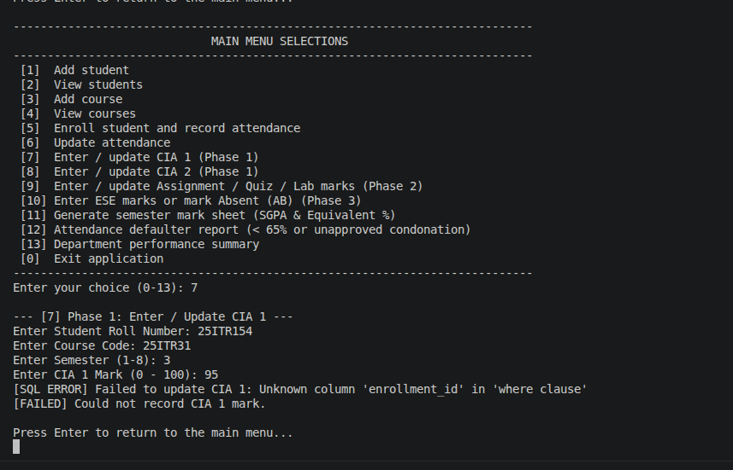

2.PHASE 2 (ENTER - CIA):
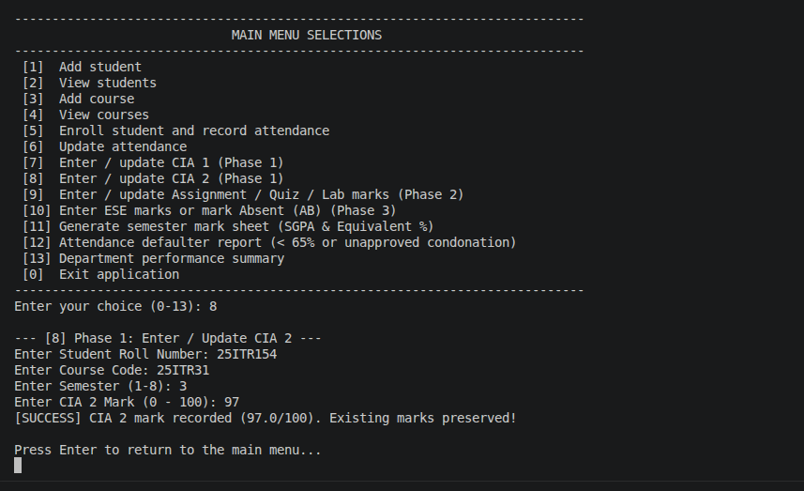

3. PHASE 2 (UPDATE ASSIGNMENT/QUIZ/LAB MARKS):
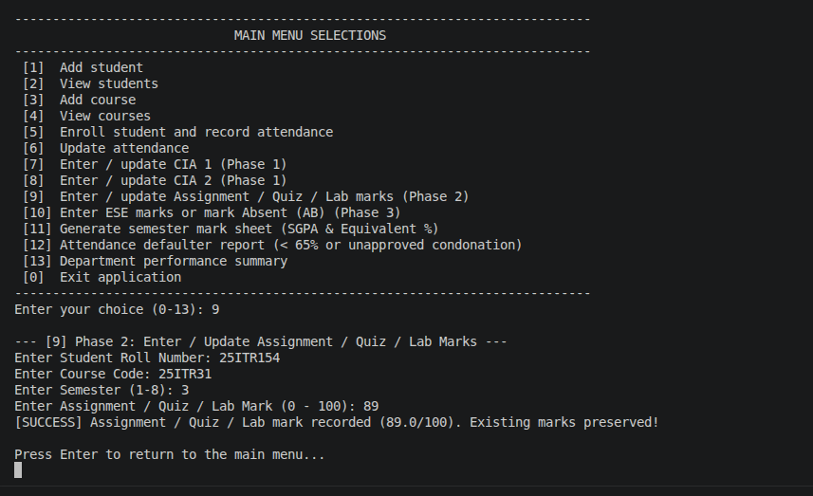

4. PHASE 3 (ENTER ESE OR ABSENT MARK):
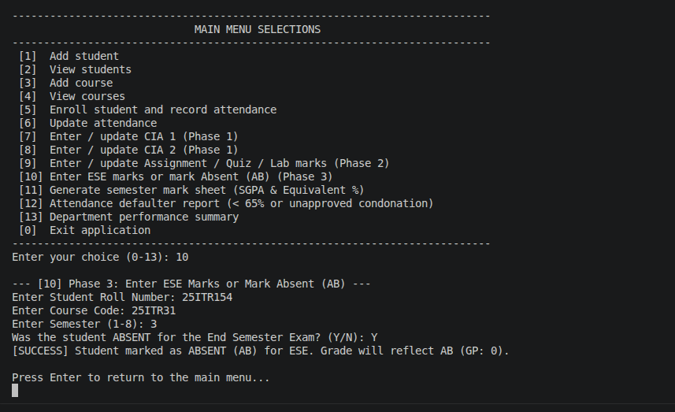

ATTENDANCE & GRADING RULES:

1.ATTENDANCE FILTER:
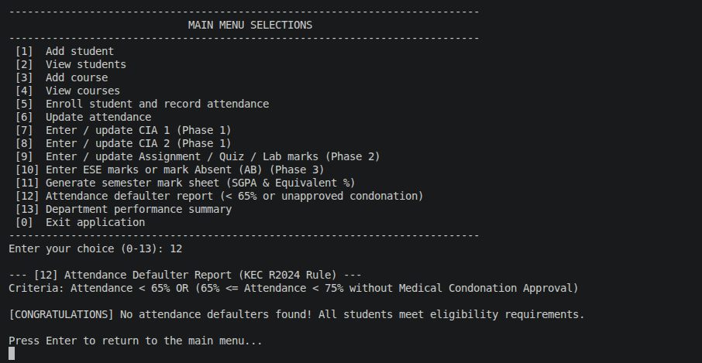

STUDENT SEMESTER MARK SHEET:
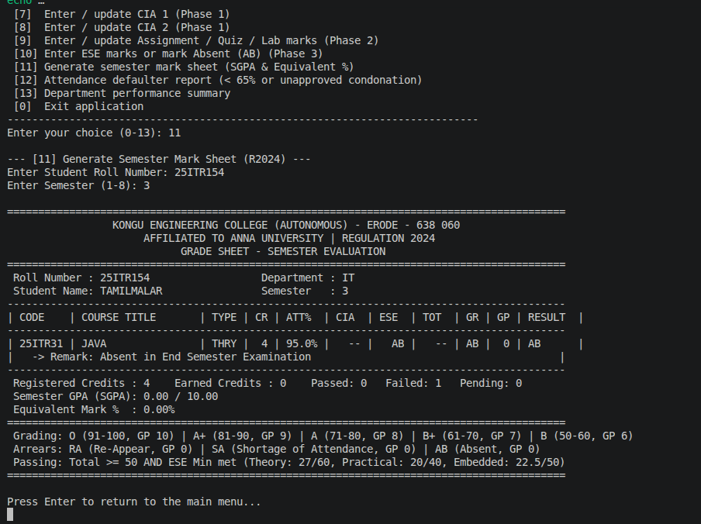

DEPARTMENT WISE CLASS PERFORMANCE & RESULT SUMMARY:
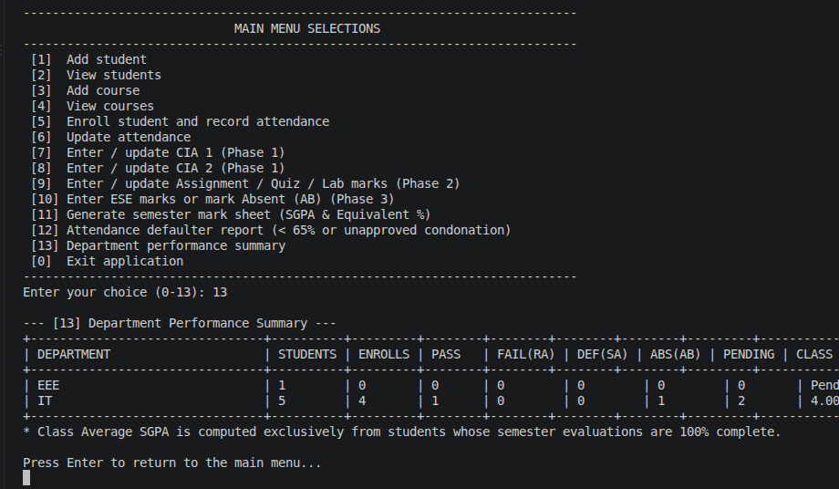

DATABASE:
STUDENTS DATABASE:
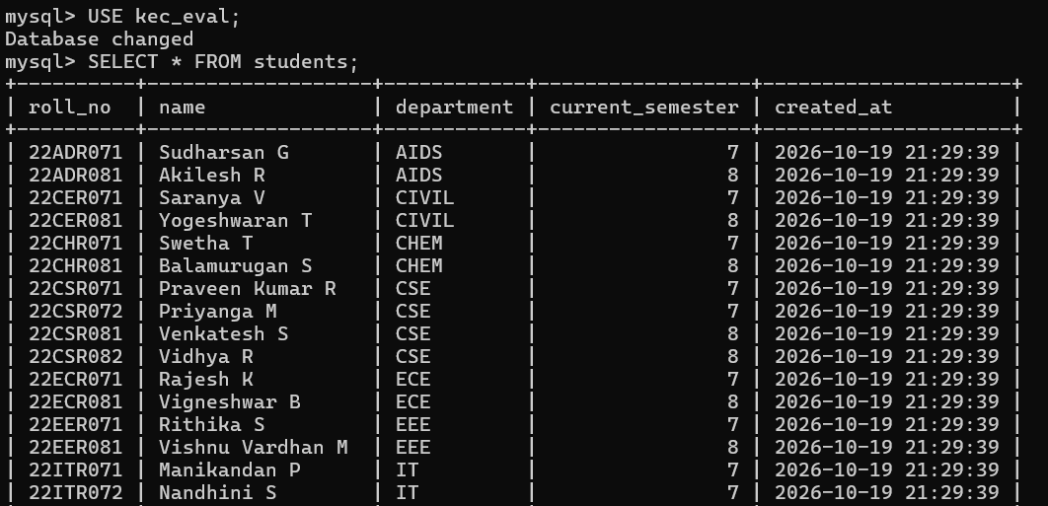

COURSES DATABASE:
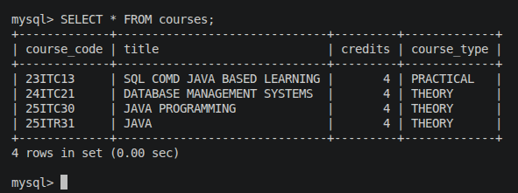

ENROLLMENTS DATABASE:
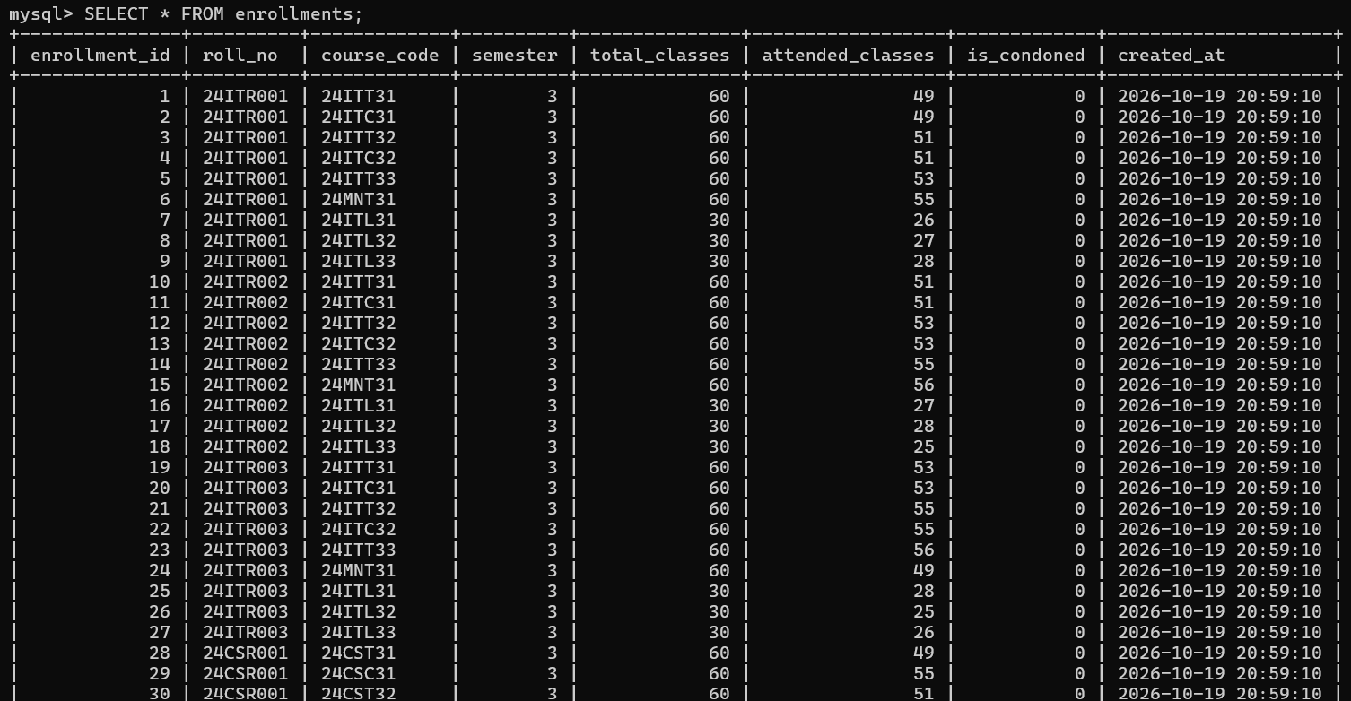

RESULT:
Thus, the Student Academic and Continuous Evaluation System for Kongu Engineering College (Autonomous) Regulation 2024 was successfully designed, developed, and tested using Java (JDBC) and MySQL. The system accurately automates the calculation of Continuous Internal Assessments (CIA), End Semester Examinations (ESE), Letter Grades, Attendance Eligibility, and Semester Grade Point Average (SGPA).

REFERENCES:
1. Oracle, Java SE Documentation – JDBC Overview and Architecture. https://docs.oracle.com/javase/8/docs/technotes/guides/jdbc/ .
2. Oracle, Java SE API – HttpServer. https://docs.oracle.com/en/java/javase/17/docs/api/jdk.httpserver/com/sun/net/httpserver/HttpServer.html .
3. Oracle, MySQL 8.0 Reference Manual. https://dev.mysql.com/doc/refman/8.0/en/ .
4. Oracle, MySQL Connector/J Developer Guide. https://dev.mysql.com/doc/connector-j/8.0/en/ .
5. University Grants Commission, Guidelines for Choice Based Credit System (CBCS). https://www.ugc.gov.in/pdfnews/8023719_Guidelines-for-CBCS.pdf .
6. Chart.js, Chart.js Documentation. https://www.chartjs.org/docs/latest/ .
7. Tailwind CSS, Tailwind CSS Documentation. https://tailwindcss.com/docs .
8. GeeksforGeeks, Establishing JDBC Connection in Java. https://www.geeksforgeeks.org/establishing-jdbc-connection-in-java/ .
9. YouTube, Java JDBC with MySQL Tutorial Videos. https://www.youtube.com/results?search_query=Java+JDBC+MySQL+tutorial .
10. Anthropic, Claude AI Assistant (used for project ideas and guidance). https://claude.ai/ .

GITHUB:
LINK: | https://github.com/Tamzz30/KEC-R2024-Student-Evaluation-System.git

